CP2406 Programming 3 Assignment 2

Phan Nguyen Minh Quan

**User Stories**

User Story 1: As a user, I want to see the simulator app as a single main window with menu bar and status bar.

User Story 2: As a user, I want to see the menu bar with 2 items: City Editor and Simulation.

User Story 3: As a user, when I click on City Editor, I should be able to see submenu items that allow me to create a new City (New), save my current City (Save), open a saved City (Open), and Exit the program (Exit).

User Story 4: As a user, when I click on Simulation, I should be able to see submenu items that allow me to load my City Map (Load Map), add vehicles to my City Map (Add Vehicles), set the update rate (Update Rate), start/run the simulator (Start), stop the simulator (Stop).

User Story 5: As a user, I want to be able to set my road Orientation as Horizontal or Vertical in my City Editor mode after I click at any point on my City.

User Story 6: As a user, when I click on the City Editor’s submenu item named New, I want to be able to click on any point on my City from where the program will draw a new Road after I choose the road Orientation to be Horizontal or Vertical.

User Story 7: As a user, I want to save my City with auto-generated names in the City Editor mode so that I can go back to view/load them later.

User Story 8: As a user, I want to be able to open/load my saved City before.

User Story 9: As a user, I want to be able to Exit the program.

User Story 10: As a user, I want to program to automatically add a Traffic Light at the end of every newly created Road.

User Story 11: As a user, I want to update vehicle rate to accelerate or decelerate vehicles in the Simulation mode.

User Story 12: As a user, I want to start my simulator app in the Simulation mode.

User Story 13: As a user, I want vehicles to keep a safe distance or at least not to crash to each other while running in the simulator.

User Story 14: As a user, I want vehicles to not enter roads when those roads are full of vehicles (the total length of all vehicles on that road plus the new vehicles exceeds the length of the road).

User Story 15: As a user, I want to be able to enter the number of vehicles that I want to add to my City in the Simulation mode.

User Story 16: As a user, I want to be able to stop my Simulator at any time in the Simulation mode.

User Story 17: As a user, I want to be able to update the rate for my simulator app in the Simulation mode.

User Story 18: As a user, I want to be able to set the vehicle spawn rate for my simulator app in the Simulation mode after adding Vehicles to my City.

User Story 19: As a user, after I enter the number of vehicles, I want the program to randomly generate vehicles from only 3 vehicles types on my simulator app: Motorbike, Car and Bus in which Motorbike’s length is only half of the length of a Car, Bus’s length is 3 times the length of a Car and the Car breadth is half of its length.

User Story 20: As a user, I want my simulator to have no roundabouts or pedestrians.

User Story 21: As a user, I want vehicles to stick to Australian rules and these specific rules when travelling on any road or interacting with each other:

1. A road is at least 2 times and at most 5 times the length of a bus.
2. A road can contain a limited number of vehicles based on the road’s length.
3. A road can have 2 lanes: right and left lanes

User Story 22: As a user, when I am in simulation mode, I should see the currently active city, current statistics about the number of vehicles, the average speed of vehicles, Simulator State, Simulator mode.

**Developer User Stories**

Developer User story 1: This story is basic and simple so the Priority is High and Estimate time is 1 day.

Developer User Story 2: Same as Developer User story 1,the Priority is High and Estimate time is 1 day.

Developer User Story 3: Adding 4 submenu items: “New, Open, Save, and Exit” to City Editor is a High Priority item which takes 1 day.

Developer User Story 4: Adding 5 submenu items: “Load Map, Add Vehicles, Update Rate, Start and Stop” to Simulation is a High Priority item which takes 1 day.

Developer User Story 5: Taking user input for the Road’s Orientation and setting it to the City is High priority and takes only 0.5 day.

Developer User Story 6: Detecting user’s mouse click, calling the method implemented in the Developer User Story 5 and drawing the Road are High priority and takes 2 days.

Developer User Story 7: Saving a City with an auto-generated name is Medium Priority and takes 1 day.

Developer User Story 8: Loading a saved City is Medium Priority but complicated, so it takes 2 days.

Developer User Story 9: Exiting the program is High Priority but very simple, should take 0 day.

Developer User Story 10: Adding and drawing Traffic Light at the end of every road is High Priority, and a bit complicated so it should take 2 days.

Developer User Story 11: Updating vehicle rate is Medium Priority and is simple, it should take 1 day to implement only.

Developer User Story 12: Triggering the simulator to run is High Priority and takes 1 day to implement.

Developer User Story 13: Keeping a safe distance between vehicles is Medium Priority and takes 1 day.

Developer User Story 14: Blocking vehicles from entering a road which is full of vehicles is Medium Priority and takes 1 day.

Developer User Story 15: Taking user input for the number of vehicles to add in the City is High Priority and takes 1 day.

Developer User Story 16: Stopping Simulator is a High Priority but very simple feature, it should take 0 day.

Developer User Story 17: Updating Simulator rate is High Priority but simple so it takes 1 day to implement

Developer User Story 18: Set the vehicle spawn rate is High Priority but simple so it takes 1 day to implement

Developer User Story 19: Randomly generating vehicles with the input of vehicle number from users is High Priority and not very simple, it should take 2 days to implement

Developer User Story 20: No roundabouts or pedestrians is Low Priority and simple, it should take 0 day.

Developer User Story 21: Ensuring vehicles sticking to strict rules specified in the User Story 21 is High Priority and not simple, it should take 3 days to implement.

Developer User Story 22: Displaying the currently active city, current statistics about the number of vehicles, the average speed of vehicles, Simulator State, Simulator mode is High Priority and takes 2 days to implement.

UML Diagram  
(next page)

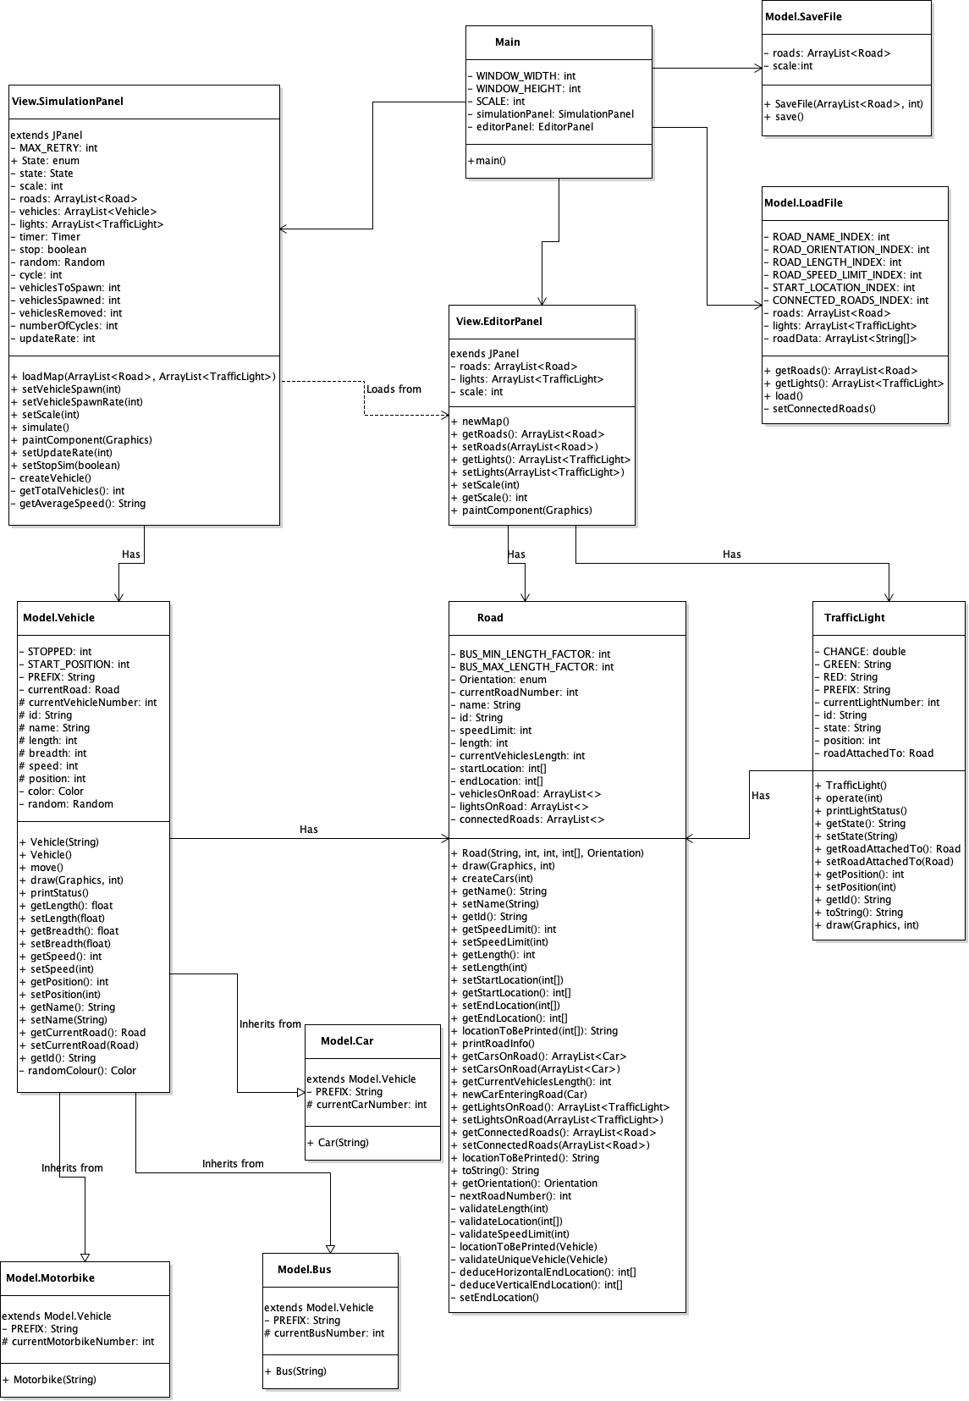

Github screenshots: